# **SCOPE OF WORK**

### Introduction

VUT has identified a need to expand its existing infrastructure, particularly in student accommodation. The expansion comes with lot of changes in terms of electrical infrastructure.

The existing electrical infrastructure is currently in a fair condition, except that it has no spare capacity to service anticipated load growth. A major upgrade of existing electrical infrastructure has been identified and quantified in the master plan report for execution. The master plan report evaluated the long-term viability of existing infrastructure and proposed projects and their requirements.

The upgrade affect Emfuleni’s Vesco Substation together with the VUT intake substations.

Application to upgrading current Notified Maximum Demand from 3MVA to 10MVA has been submitted to Emfuleni Local Municipality. The application is approved with conditions that the existing Emfuleni’s Vesco substation is strengthened with additional 20MVA transformer to meet current and future demand. There is a project underway to install additional 20MVA transformer. The project will be running concurrent with the execution of the implementation of the master plan.

The proposed project as per the master plan report, will be executed in Phase 1 and   
Phase 2. This is merely because of the funds allocation.

# **VUT Locality Map and Load Growth Points**

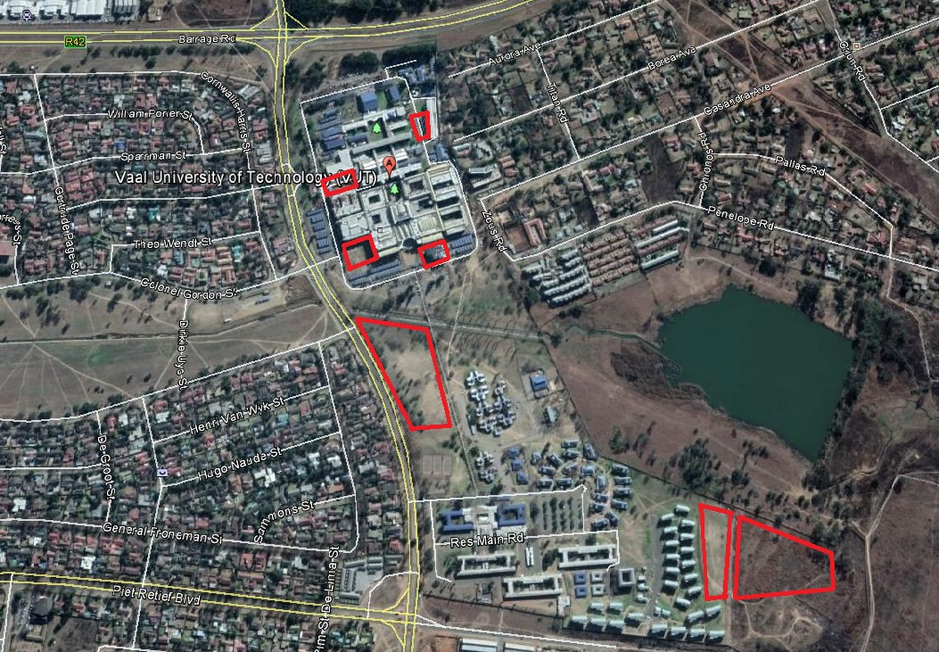

Student Housing Complex (500kVA)

Student Housing Complex (1000kVA)

Student Housing Complex (1000kVA)

African Languages & Disability Centre (500kVA)

Future (600kVA)

Physical Science Building (800kVA)

Engineering Building Computer Centre (200kVA)

Figure 1: Depict VUT Locality Map and Load Growth Points

# **Project Scope of Work**

### Bulk supply

Master Plan Report has proposed New VUT Switching Substation which will be fed from the existing Emfuleni’s Vesco Substation. There will be few adjustments inside Vesco substation to accommodate 3 x new switchgears and bulk supply cables from Vesco Substation to new VUT Switching substation. All the works below will be done under Phase 1.

Work to be carried out at Vesco and New VUT substations is as follows:

* Existing 1 x switchgears at Vesco substation dedicated for VUT will be decommissioned and replaced with 3 x Medium Voltage Tamco switchgears.
* Installation of 3 x 185mm2 3-core Cu XLPE bulk supply cables from Vesco substation to New VUT switching substation (1500m).
* Installation of differential protection scheme for bulk supply cables between Vesco substation and new VUT switching substation.
* Optical fibre for protection between Vesco and New VUT switching substation.
* Existing Vesco Substation – 11kV Switchgears Layout

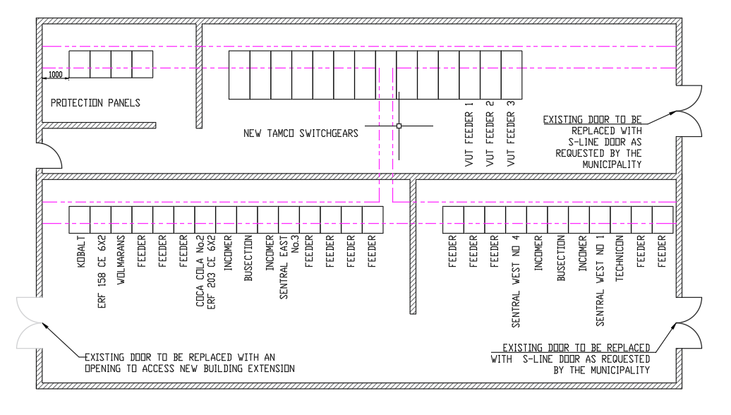

Figure 2:Existing Vesco substation – 11kV Switchgears Layout (Floor plan)

# **New VUT switching substation**

The switching station shall comprise of 3 x metalclad switchgear incomers, 3 x metalclad feeders dedicated to feed existing Main Sub (Block D), Prima Sub and proposed Miniature Substation (Block KW). The total capacity of the switching substation shall be 11kV, 23MVA and 1250A busbar rated. Design of the building is as per Emfuleni Local Municipality standard switching substation equipment layout.

The substation building is equipped with the following:

* 2 x 36W open channel fluorescent light fitting
* 16A Single liver light switch
* 16A Double switched socket outlet
* Outside building lighting - 2 x 9W Bulkhead light fitting
* Light control day/night - Photocell
* Low voltage distribution Board
* Fire extinguisher
* Medical aid box

Below is the New VUT Switching Substation Building and Switchgears Layout.

